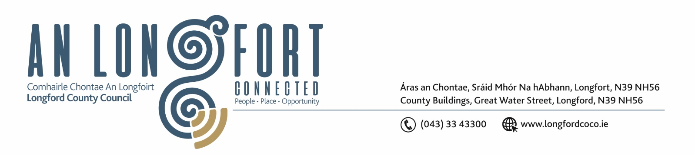

8th Marta 2018.

Chuig: Gach Ball don Chomhairle.

A Chomhairleoir,

Iarrtar ort bheith i láthair ag Cruinniú Míosuil Chomhairle Chontae Longfoirt a tionólfar i Seomra na Comhairle, Aras an Chontae, Longford ar an Chéadaoin, 14u Marta 2018 ag 4.00 p.m chun gnó a dhéanamh d’réir an Chláir thíos.

You are requested to attend the Monthly Meeting of Longford County Council to be held in the Council Chamber, Aras an Chontae, Great Water Street, Longford on Wednesday, 14th March 2018 at 4.00 p.m. to transact business, as set out on the Agenda hereunder.


Mise le meas,

__________________
Anne Lee,
Meetings Administrator.

C L A R

- Confirmation of Minutes of Monthly Meeting of Longford County Council held on the
14th February 2018 – copy enclosed.

- Matters arising from Minutes.

- To note Chief Executive Orders - enclosed.

4 . To note Monthly Management Report - to follow.

5. To note adopted Minutes of Corporate Policy Group Meeting held on
10th January 2018 - enclosed.

6. Finance & Information Systems.

- To note Public Liability Claims received during February 2018.

- Consideration of Capital Budget – to follow.

7. Economic and Community Development, Planning, Human Resources & Corporate Services, Cultural & Recreational Services.

- To note Planning Applications received since February meeting of the Council.

- (i) To note adopted Minutes of Economic Development and Enterprise Strategic Policy Committee Meeting held on the 18th December 2017.

(ii) To note adopted Minutes of Planning and Development and Cultural Strategic Policy Committee Meeting held on the 11th December 2017

- Update regarding proposed Twinning with Baltimore, Maryland, USA.

- Development Contribution Scheme 2018 – 2022 - report enclosed.

- Appointment of Mr. Oliver Cassidy, Granard Traders Association, to replace Mr. Joe Flaherty as a member of Longford Local Community Development Committee (LCDC).

- Consideration of disposal of land at Templemichael Business Park, Ballinalee Road, Longford containing 0.072 acres to N & E Farrell Precision Engineering Ltd. Templemichael Business Park, Longford in accordance with the terms of Section 183 of the Local Government Act 2001 issued on the 26th February 2018.

- Consideration of 2017 Audit Committee Annual Report – to follow.

- Set dates for Annual Meetings of Longford County Council and Municipal Districts Committees.

8. Housing, Infrastructure, Environment & Emergency Services.

- (i) To note adopted Minutes of Housing Services Strategic Policy Committee Meeting held on the 7th November 2017.
(ii) To note adopted Minutes of Infrastructure and Environment Strategic Policy Committee Meeting held on the 14th December 2017.

- Community Involvement Scheme.

9. General.

- Correspondence – enclosed.

- Correspondence dated 14th February 2018 received from the Office of the Minister for Housing regarding commercial rates for private early years services.

(ii) Notices of Motions, submitted by Councillors, as listed hereunder –

Councillor Mark Casey.
“That this Council writes to the Minister for Health seeking funding/resources from the Department of Health and Department of Education to cut child psychology waiting lists. Currently there are over 7,000 children on a waiting list to for psychological interventions.”
Councillor Michael Carrigy
“I call on Longford County Council to write to the Minister for Agriculture Michael Creed to support the IFA campaign to ensure a payment of €200 per suckler cow .”

Councillor Luie McEntire.

“That this Council calls on the Minister for Agriculture, Deputy Michael Creed, to ensure that a payment of €200 per cow up to a certain number be paid to Suckler Farmers and that Single Farm Payment continue for smaller part-time farmers, as they are now at a difficult decision time.”

Councillor John Browne.

“I call on Longford County Council to write to The Minster for Finance Pascal Donohoe TD and the Central Bank calling for legislation to be enacted so as to compel Vulture Funds , on acquiring loan books from financial institutions that they are legally bound, to inform mortgage holders of the price paid for each loan.
The borrower on being informed of the price paid be given a period of time to purchase or discharge the loan for the amount paid by the Vulture Fund for the loan.”

11. Votes of sympathy.



